isEducation ↔ CRM Contact: Field Mapping Logic
Context: One-to-one link between isEducation Profile and Dynamics 365 Contact. Sync is bi-directional for these fields unless noted.

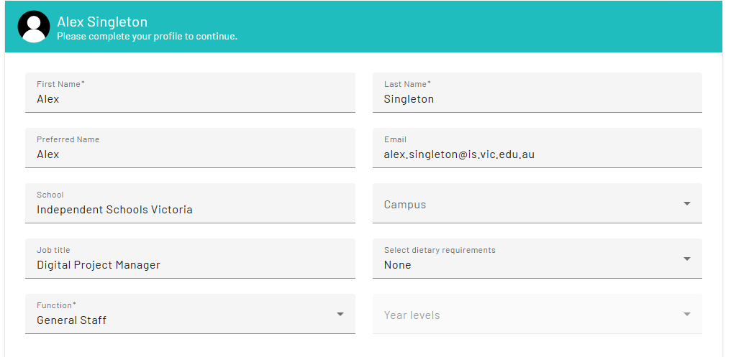

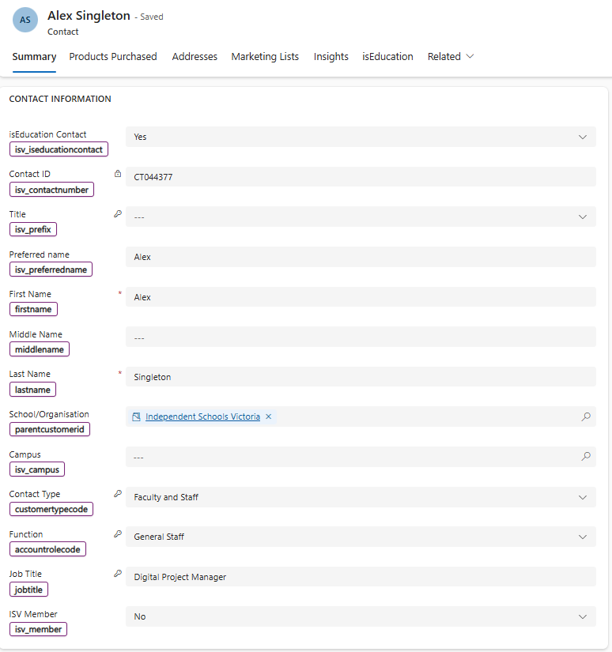

# | Portal label (UI) | CRM display name | CRM logical name | Data type | Sync direction | Notes / Values / Examples (updated with your clarifications)
1 | isEducation Contact | isEducation Contact | isv_iseducationcontact | Two-Option (Boolean) | Not Present in isEducation | Not Visible on the isEducation profile. Set to Yes in CRM automatically when a new user completes isEducation registration.  Values: Yes/No.
2 | Contact ID | Contact ID | isv_contactnumber | Text (read-only) | No Sync | Not currently used in the isEducation portal. Generated/owned by CRM upon contact being created in Dynamics
3 | Title | Title | isv_prefix | Option set | Not Present in isEducation | Not currently used in the isEducation portal. Updated in CRM only. Can be used for marketing purposes where Prefix code is added to correspondence.
4 | Preferred Name | Preferred name | isv_preferredname | Free Text | Bi-directional | Used in both CRM and the isEducation portal. Optional on the portal. Used for CRM communications/marketing (e.g., “Dear <Preferred Name>”).
5 | First Name | First Name | firstname | Text (required) | Bi-directional | Used in both the isEducation portal and CRM. Mandatory field on both platforms.
6 | Middle Name | Middle name | middlename | Text | Not Present in isEducation | Not currently used in the isEducation portal. Maintained in CRM only. Optional Field.
7 | Last Name | Last Name | lastname | Text (required) | Bi-directional | Used in both the isEducation portal and CRM. Mandatory field on both platforms.
8 | School / Organisation | School/Organisation | parentcustomerid (lookup → account) | Lookup | Bi-directional | Lookup to the user’s School/Organisation. Sync includes Account name + GUID. Auto-linking rule: Accounts hold allowed email domain(s) (see screenshot after #13). If a user registers with a matching domain, the Contact is automatically linked to that Account and the ISV Member flag is set to mirror the School’s membership.
9 | Campus | Campus | isv_campus | Lookup based on Parent Account | Bi-directional | Present on the isEducation profile but not mandatory. The Campus options available to select are determined based on School linked to profile.
10 | Contact Type | Contact Type | customertypecode | Option set | Not Present in isEducation | Not Visible on the isEducation profile. Automatically set to “Faculty and Staff” in CRM upon isEducation registration.
11 | Function | Function | accountrolecode | Option set | Bi-directional | Mandatory for users to select in the isEducation portal. Rendered as a dropdown sourced from CRM options (e.g., General Staff, Principal, Business Manager, Admin).  When a user selects Teacher or Teacher – Non-Teaching Role, additional fields become visible in the portal based on CRM logic:  - Teaching Discipline (dropdown)  - Year Levels (dropdown)  These conditional fields collect more detail about teaching-related roles and sync back to CRM where applicable. All other Functions only display the basic mandatory fields.
12 | Job Title | Job Title | jobtitle | Free Text | Bi-directional | Free-text field in the isEducation portal (sourced from CRM schema); updates like-for-like between systems.
13 | ISV Member | ISV Member | isv_member | Two-Option (Boolean) | Bi-directional | Not Visible on the isEducation profile.See #8 auto-linking rule: when a registering user’s email domain matches an Account’s allowed domain(s) and the Contact is linked to that Account, isv_member is set to reflect the School’s membership. Values: Yes/No.

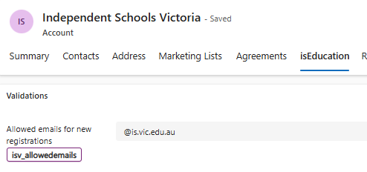

14 | Select dietary requirements | Dietary Requirements | isv_dietaryreq | Multi-select (portal); multi-select/option set/text (CRM) | Bi-directional | Appears in the portal as a multi-select list (e.g., Diabetic, Halal, Kosher, Vegan, Vegetarian, Gluten Free, Lactose Free). None indicates no requirements. Selections sync to CRM isv_dietaryreq and display on the Contact form. Used by Events/PL for catering and logistics. Optional on portal.
15 | Other Dietary Requirements | Other Dietary Requirements | isv_dietaryrequirementsother | Text (free-text) | Bi-directional | Only shows in the portal when Other is selected in Dietary Requirements. Captures details not covered by the predefined list. Syncs to CRM isv_dietaryrequirementsother and displays under the Dietary Requirements section
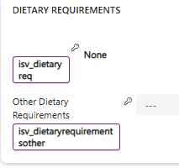

16 | Email | Email | emailaddress1 | Email (text) | Bi-directional but cannot be updated in isEducation | Primary email used for isEducation portal login, identity verification, and CRM communications. Critical for School auto-linking at registration (domain must match the School’s allowed registration domain/s). The email field is locked in the isEducation profile and cannot be edited by the user. Email can be updated in CRM, but only by System Administrators due to identity impacts.  Updating the email in CRM will sync to the portal; however, it will break the user’s ability to sign in, because the original email is the unique identifier stored in Azure AD B2C at registration. At present, if an email change is required, the user must re-register for isEducation using a new email address.

